# Practical Guide 06 – Part II

**I.**

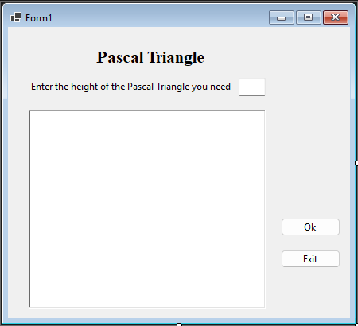

**III.**

namespace PascalTriangle

{

public partial class Form1 : Form

{

public Form1()

{

InitializeComponent();

}

private void btnExit_Click(object sender, EventArgs e)

{

this.Close();

}

private void btnOk_Click(object sender, EventArgs e)

{

richTextBox1.Text = "";

try

{

int length = int.Parse(txtNumber.Text);

long[][] triangle = new long[length + 1][];

for (int row = 0; row < length; row++)

{

triangle[row] = new long[row + 1];

}

// Calculate the Pascal's triangle

triangle[0][0] = 1;

for (int row = 0; row < length - 1; row++)

{

for (int col = 0; col <= row; col++)

{

triangle[row + 1][col] += triangle[row][col];

triangle[row + 1][col + 1] += triangle[row][col];

}

}

// Print the Pascal's triangle

for (int row = 0; row < length; row++)

{

richTextBox1.Text = richTextBox1.Text + "".PadLeft((length - row) * 2);

for (int col = 0; col <= row; col++)

{

richTextBox1.Text = richTextBox1.Text + triangle[row][col];

}

richTextBox1.Text = richTextBox1.Text + Environment.NewLine;

}

}

catch (FormatException)

{

MessageBox.Show("Please enter a number to the length");

}

}

}

}

**IV.**

